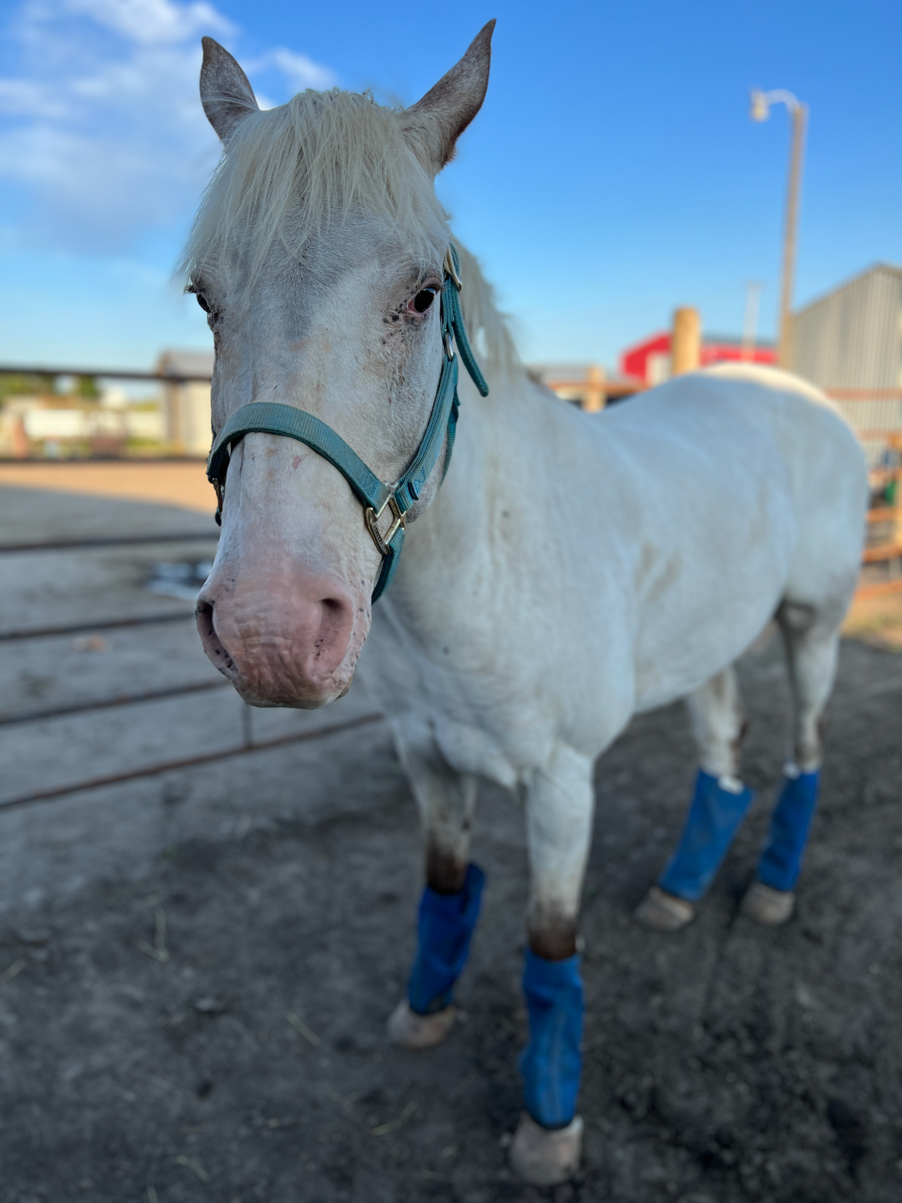2024 Scholarship Form

TODAYS DATE: FORM COMPLETED BY:

How did you hear about Spirit of Wonder?

Scholarship granting may be limited due to amount of funds available. All grants are based on financial need. Please talk with the program contact person with any additional questions. Scholarships are available on a first come basis.

 Occupational Therapy/Speech Therapy using Equine Movement (Hippptherapy)

Parent/Caregiver is requesting:  10% Discount  30% Discount

 20% Discount  40% Discount

Is this the first-time receiving a scholarship from Spirit of Wonder? If no, what year was the scholarship granted:

yes no

Demographic Information:

Child’s Name: _______________________________________________ DOB: ______________________ Gender: ____________

Parent/Guardian Name: _______________________________________________________________________________________

Parent/Guardian Phone Number: _______________________________________________________________________________

Parent/Guardian Email Address: ________________________________________________________________________________

Financial Information:

*All information on this form is strictly confidential and will only be viewed by the Scholarship Committee.

Number of dependent children: Ages:

An accurate completed form will assist in determining if you are eligible for a scholarship. The worksheet below will help ensure that you include all income sources and all regular monthly expenses. Please enter the information on page 2 to the best of your knowledge. If an area does not apply, please write N/A. Form must be completed in its entirety in order to be considered for a scholarship. Prior month proof of payroll to be included with application. Based on information submitted, additional information/documentation may be required.

CHECKLIST PRIOR TO SUBMITTING:

 Fully completed form (2 full pages)  Payroll proof from previous month  Most recent tax return

# Please complete form and return to:

# "Spirit of Wonder"

664 12th St W Suite C Dickinson, ND 58601

*this application due 3 weeks prior to camp start date

Any questions, please contact Jenna at

[jenna.weisz@wondermenttherapies.com](mailto:jenna.weisz@wondermenttherapies.com)

page 1 of 2

2024 Scholarship Form

INCOME / MONEY COMING IN

This information will be obtained from: Most current tax return and most recent proof of payroll

EXPENSES / MONEY GOING OUT

Home Mortgage/Rent Real Estate Tax or Fees

Home Equity Line of Credit payment Car Payments

Boat/Camper Payment Monthly Daycare Payment

Utilities (Heat/Water/Garbage, Electricity Phone/Cable)

Insurances: Car, Life; Medical

Monthly Credit Card payments

Monthly Essentials (Groceries, Clothing, Gas for Vehicle, Medications)

Other Debt not stated above Total monthly Debt

MONTHLY EXPENSE COMMENTS

$

$

$

$

$

$

$

$

$

$

$

$

CONDITIONS OF APPLICATION

Application is hereby made for the above-named client at Spirit of Wonder.

Acceptance of this client for engagement in hippotherapy, groups/camps, and with the consents, in this application stated.

I hereby agree as follows:

1. To deliver the client to Spirit of Wonder/Wonderment Therapies on time for all scheduled appointment dates/ times.
2. To waive and relinquish any and all claims or liabilities against Spirit of Wonder/Wonderment Therapies, their associated, affiliated or parent bodies.

ALTERING THIS APPLICATION IN ANY WAY WILL RESULT IN DISAPPROVAL

Printed Name Relationship: Parent Guardian Other:

Caregiver / Guardian Signature Date:

action of board of directors

Details:

Based on financial qualifications, you were granted $

Spirit of Wonder Representative Signature

Date

page 2 of 2